Android开发技术教程
-----布局技术（Layout）

代码 | 说明
LinearLayoutExec | 用XML文件配置的LinearLayout
LinearLayoutJava | 用JAVA实现的LinearLayout
UITableLayout | 用XML文件配置的TableLayout
UITableLayoutJAVA | 用JAVA实现的TableLayout
UIFrameLayout | 用XML文件配置的FrameLayout
UIFrameLayout | 用JAVA实现的FrameLayout
UIRelaviteLayoutExec | 用XML文件实现的相对布局
UILinearTableLayoutExec | 用XML文件实现的线性和表格布局实现的菜单

LinearLayout线形布局
ava.lang.Object
↳ | android.view.View
 | ↳ | android.view.ViewGroup
 |  | ↳ | android.widget.LinearLayout
LinearLayoutExec（用XML文件配置的LinearLayout）
线性布局在缺省情况下是水平方向，我们在程序的activity_main.xml中输入
代码LinearLayoutExec-1:Res/layout/activity_main.xml
- <RelativeLayout xmlns:android="http://schemas.android.com/apk/res/android"
- xmlns:tools="http://schemas.android.com/tools"
- android:layout_width="match_parent"
- android:layout_height="match_parent"
- android:paddingBottom="@dimen/activity_vertical_margin"
- android:paddingLeft="@dimen/activity_horizontal_margin"
- android:paddingRight="@dimen/activity_horizontal_margin"
- android:paddingTop="@dimen/activity_vertical_margin"
- tools:context=".MainActivity" >
- <LinearLayout
- android:id="@+id/linearlayout1"
- android:layout_width="wrap_content"
- android:layout_height="wrap_content" >
- <Button
- android:id="@+id/bnt1"
- android:text="@string/bntText"
- android:layout_width="wrap_content"
- android:layout_height="wrap_content" >
- </Button>
- <Button
- android:id="@+id/bnt1"
- android:text="@string/bntText"
- android:layout_width="wrap_content"
- android:layout_height="wrap_content" >
- </Button>
- <Button
- android:id="@+id/bnt2"
- android:text="@string/bntText"
- android:layout_width="wrap_content"
- android:layout_height="wrap_content" >
- </Button>
- <Button
- android:id="@+id/bnt3"
- android:text="@string/bntText"
- android:layout_width="wrap_content"
- android:layout_height="wrap_content" >
- </Button>
- </LinearLayout>
- </RelativeLayout>
运行的结果是：
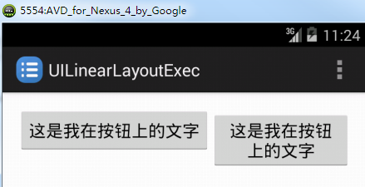
在Linearlayout中加入设置布局方向的代码 android:orientation="vertical"

LinearLayoutJava(用JAVA实现的LinearLayout)
用JAVA代码实现线性布局和内嵌的组件
- package com.example.uilinearlayoutjava;
- import android.os.Bundle;
- import android.app.Activity;
- import android.graphics.Color;
- import android.util.TypedValue;
- import android.view.Gravity;
- import android.view.Menu;
- import android.view.ViewGroup;
- import android.widget.Button;
- import android.widget.LinearLayout;
- import android.widget.TextView;
- import android.widget.LinearLayout.LayoutParams;
- public class MainActivity extends Activity {
- @Override
- protected void onCreate(Bundle savedInstanceState) {
- super.onCreate(savedInstanceState);
- //因为在activity_main.xml里面没有任何的布局文件信息，因此下面这条语句失效setContentView(R.layout.activity_main);
- //生成XML文件的线性布局
- LinearLayout linearlayout=new LinearLayout(this);
- //导入XML文件的线性布局-设置布局的参数
- LayoutParams linearParams=new LayoutParams(
- ViewGroup.LayoutParams.MATCH_PARENT,
- ViewGroup.LayoutParams.MATCH_PARENT );
- linearlayout.setOrientation(LinearLayout.VERTICAL);
- linearParams.gravity=Gravity.CENTER_VERTICAL;
- linearlayout.setLayoutParams(linearParams);
- super.setContentView(linearlayout);
- //用代码方式来创建布局//生成文本组件，并设置它的属性
- TextView textview1=new TextView(this);
- textview1.setText("我是用JAVA代码生成的");
- textview1.setTextSize(TypedValue.COMPLEX_UNIT_PX,24);
- textview1.setTextColor(Color.RED);
- LayoutParams params=new LayoutParams(
- ViewGroup.LayoutParams.WRAP_CONTENT,
- ViewGroup.LayoutParams.WRAP_CONTENT);
- params.gravity=Gravity.CENTER;
- textview1.setLayoutParams(params);
- linearlayout.addView(textview1);
- //生成按钮组件，并设置它的属性for (int i=0;i<5;i++){
- Button bnt=new Button(this);
- bnt.setText("用程序生成的按钮");
- bnt.setBackgroundColor(Color.GREEN);
- bnt.setTextColor(Color.YELLOW);
- LayoutParams bntparams=new LayoutParams(
- ViewGroup.LayoutParams.WRAP_CONTENT,
- ViewGroup.LayoutParams.WRAP_CONTENT);
- bntparams.gravity=Gravity.CENTER;
- bnt.setLayoutParams(bntparams);
- linearlayout.addView(bnt);
- }
- }
运行的结果是
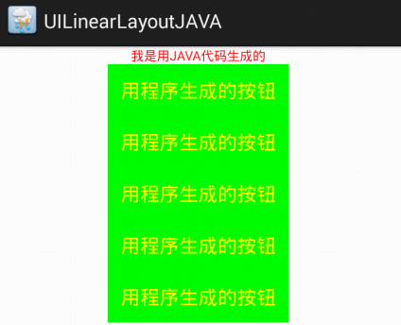
TableLayout表格布局
java.lang.Object
↳ | android.view.View
 | ↳ | android.view.ViewGroup
 |  | ↳ | android.widget.LinearLayout
 |  |  | ↳ | android.widget.TableLayout
XML属性
Attribute Name | Related Method | Description
android:collapseColumns | setColumnCollapsed(int,boolean) | The zero-based index of the columns to collapse.
android:shrinkColumns | setShrinkAllColumns(boolean) | The zero-based index of the columns to shrink.
android:stretchColumns | setStretchAllColumns(boolean) | The zero-based index of the columns to stretch.

运行的结果
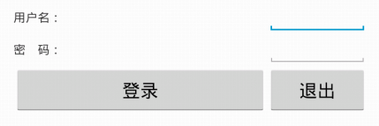

UITablelayout（用XML文件配置的表格布局）

UITableLayoutJAVA（用JAVA编程方式实现表格布局）（自学）
- <TableLayout android:id="@+id/tableLayout1"
- android:layout_width="fill_parent"
- android:layout_height="fill_parent"
- android:gravity="center_vertical"
- android:stretchColumns="0,3" ></TableLayout>

- package com.example.uitablelayoutjava;
- import android.os.Bundle;
- import android.app.Activity;
- import android.widget.Button;
- import android.widget.TableLayout;
- import android.widget.TableRow;
- public class MainActivity extends Activity {
- private Button[][] bnt=new Button[3][3];
- private TableRow[] tablerow=new TableRow[3];
- private int intnum;
- @Override
- protected void onCreate(Bundle savedInstanceState) {
- super.onCreate(savedInstanceState);
- super.setContentView(R.layout.activity_main);
- TableLayout tablelayout=(TableLayout)findViewById(R.id.tableLayout1);
- //用编程的方式控制每个按钮的显示内容
- for (int i=0;i<bnt.length;i++){
- tablerow[i]=new TableRow(this);
- for(int j=0;j<bnt[i].length;j++){
- String strsum=Integer.toString(intnum++);
- bnt[i][j]=new Button(this);
- bnt[i][j].setText(strsum);
- bnt[i][j].setHeight(240);
- bnt[i][j].setWidth(240);
- tablerow[i].addView(bnt[i][j]);
- }
- tablelayout.addView(tablerow[i]);
- }
- }
- }

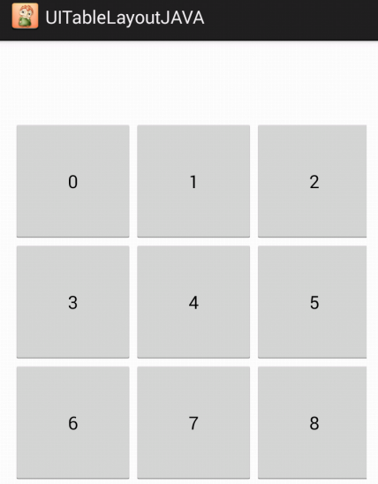

FrameLayout帧布局
java.lang.Object
↳ | android.view.View
 | ↳ | android.view.ViewGroup
 |  | ↳ | android.widget.FrameLayout

Attribute Name | Related Method | Description
android:foreground | setForeground(Drawable) | Defines the drawable to draw over the content.
android:foregroundGravity | setForegroundGravity(int) | Defines the gravity to apply to the foreground drawable.
android:measureAllChildren | setMeasureAllChildren(boolean) | Determines whether to measure all children or just those in the VISIBLE or INVISIBLE state when measuring.

UIFrameLayout用XML文件配置帧布局
运行的结果
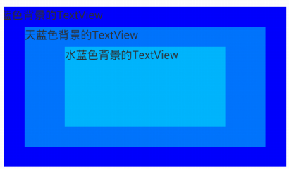

UIFrameLayoutJAVA（自学）
用JAVA实现FrameLayout
- package com.example.uiframelayoutjava;
- import android.os.Bundle;
- import android.app.Activity;
- import android.graphics.Color;
- import android.view.Gravity;
- import android.view.ViewGroup;
- import android.widget.Button;
- import android.widget.FrameLayout;
- import android.widget.TextView;

- public class MainActivity extends Activity {
- @Override
- protected void onCreate(Bundle savedInstanceState) {
- super.onCreate(savedInstanceState);
- //因为整个布局都是用JAVA生成，所以下面的代码无效！
- //setContentView(R.layout.activity_main);
- //生成一个帧布局
- FrameLayout framelayout= new FrameLayout(this);
- framelayout.setBackgroundColor(Color.GREEN);
- FrameLayout.LayoutParams layoutparam=new FrameLayout.LayoutParams(
- ViewGroup.LayoutParams.MATCH_PARENT,
- ViewGroup.LayoutParams.MATCH_PARENT);
- framelayout.setLayoutParams(layoutparam);

- //生成TextView组件
- TextView textview=new TextView(this);
- textview.setText("帧布局真的好吗？");
- textview.setBackgroundColor(Color.BLUE);
- FrameLayout.LayoutParams textviewparams=new FrameLayout.LayoutParams(400,400);
- textviewparams.gravity=Gravity.CENTER;
- textview.setLayoutParams(textviewparams);
- framelayout.addView(textview);

- //生成一个Button组件
- Button button=new Button(this);
- button.setText("我在帧布局里面");
- button.setBackgroundColor(Color.RED);
- FrameLayout.LayoutParams buttonparam = new FrameLayout.LayoutParams(200,200);
- buttonparam.gravity=Gravity.CENTER;
- button.setLayoutParams(buttonparam);
- framelayout.addView(button);

- //将组件添加到布局中
- super.setContentView(framelayout);
- }
- }

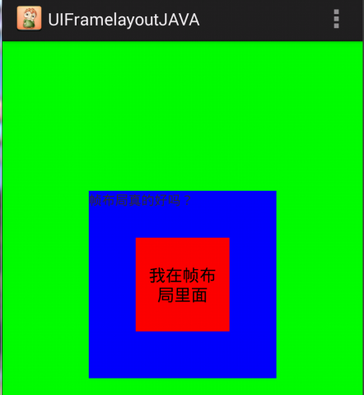

RelativeLayout相对布局
java.lang.Object
↳ android.view.View
↳ android.view.ViewGroup
↳ android.widget.RelativeLayout
.file:///C:/adt-bundle-windows-x86-20131030/sdk/docs/reference/android/widget/RelativeLayout.LayoutParams.html

Attribute Name | Description
android:layout_above | Positions the bottom edge of this view above the given anchor view ID.
android:layout_alignBaseline | Positions the baseline of this view on the baseline of the given anchor view ID.
android:layout_alignBottom | Makes the bottom edge of this view match the bottom edge of the given anchor view ID.
android:layout_alignEnd | Makes the end edge of this view match the end edge of the given anchor view ID.
android:layout_alignLeft | Makes the left edge of this view match the left edge of the given anchor view ID.
android:layout_alignParentBottom | If true, makes the bottom edge of this view match the bottom edge of the parent.
android:layout_alignParentEnd | If true, makes the end edge of this view match the end edge of the parent.
android:layout_alignParentLeft | If true, makes the left edge of this view match the left edge of the parent.
android:layout_alignParentRight | If true, makes the right edge of this view match the right edge of the parent.
android:layout_alignParentStart | If true, makes the start edge of this view match the start edge of the parent.
android:layout_alignParentTop | If true, makes the top edge of this view match the top edge of the parent.
android:layout_alignRight | Makes the right edge of this view match the right edge of the given anchor view ID.
android:layout_alignStart | Makes the start edge of this view match the start edge of the given anchor view ID.
android:layout_alignTop | Makes the top edge of this view match the top edge of the given anchor view ID.
android:layout_alignWithParentIfMissing | If set to true, the parent will be used as the anchor when the anchor cannot be be found for layout_toLeftOf, layout_toRightOf, etc.
android:layout_below | Positions the top edge of this view below the given anchor view ID.
android:layout_centerHorizontal | If true, centers this child horizontally within its parent.
android:layout_centerInParent | If true, centers this child horizontally and vertically within its parent.
android:layout_centerVertical | If true, centers this child vertically within its parent.
android:layout_toEndOf | Positions the start edge of this view to the end of the given anchor view ID.
android:layout_toLeftOf | Positions the right edge of this view to the left of the given anchor view ID.
android:layout_toRightOf | Positions the left edge of this view to the right of the given anchor view ID.
android:layout_toStartOf | Positions the end edge of this view to the start of the given anchor view ID.

UIRelativeLayout用XML文件配置相对布局



